Project Profile
- Project Profile
Project Name: AeroFlow – Flight Disruption Recovery & Passenger Service Platform
Type of Application: Web-based flight management and passenger service application
Project Description: AeroFlow is a web application designed to support flight-related operations and passenger services, particularly during flight disruptions. The project aims to organize flight and airport information and support recovery-related workflows. The system provides a platform for managing relevant information and improving the handling of flight disruptions.

Team Size: 2
Front End: HTML , CSS , Java Script, Django Templates
Back End: Python, Django Framework
Tools used:
- Programming Language: Python
- Web Framework: Django (4.2 or later, below 5.1)
- Database: SQLite
- PDF Generation: ReportLab
- QR Code Generation: qrcode
- Image Processing: Pillow
- Code Editor: Visual Studio Code
- Version Control: Git and GitHub
- Browser: Google Chrome or Microsoft Edge

Introduction to tools

- Introduction to Tools

- Front End Tool:

HTML (HyperText Markup Language)
HTML is used to create the basic structure of web pages. It defines elements such as headings, forms, buttons, tables, links, and other components displayed to users.
In AeroFlow, HTML is used to design pages for passenger registration, login, flight search, booking details, and other application features.

CSS (Cascading Style Sheets)
CSS is used to control the appearance and layout of web pages. It helps define colors, fonts, spacing, borders, alignment, and page layouts.
In AeroFlow, CSS is used to make the application interface clear, consistent, and user-friendly.

JavaScript
JavaScript is a scripting language used to add interactive behavior to web pages. It can respond to user actions, validate inputs, and update parts of the interface dynamically.
In AeroFlow, JavaScript can support interactive elements such as form validation, dropdown selections, and other client-side operations where implemented.

Django Template Language (DTL)
Django Template Language is used to display dynamic data in HTML templates. It supports template variables, loops, conditional statements, and template inheritance.
In AeroFlow, Django templates connect the user interface with data and information supplied by the Django back end.

- Back End Tool:

Python
Python is a high-level programming language known for its simple syntax and readability. It is widely used for web development, automation, data processing, and application development.
In AeroFlow, Python is used to implement application logic, process passenger requests, manage flight-related operations, and support booking and recovery workflows.

Django Framework
Django is a high-level Python web framework that supports the development of secure and maintainable web applications. It provides built-in features for URL routing, database operations, authentication, form handling, and template rendering.
In AeroFlow, Django is used to develop the main application, manage passenger and administrator operations, process bookings, and handle flight disruption recovery functions.

- Database Tool

SQLite
SQLite is a lightweight relational database management system that stores data in a database file. It does not require a separate database server and is suitable for small applications and prototypes.
In AeroFlow, SQLite is used to store and manage application data, including flight details, passenger information, bookings, and other records defined in the project.

System Study
1. Existing System
In the existing system, flight management and passenger services may involve separate processes for maintaining flight information, handling bookings, and communicating flight-related updates. During flight disruptions, passengers may face difficulties obtaining updated information and understanding the available recovery options.
Manual handling of flight records and passenger requests can require additional time and effort. Maintaining booking information, issuing travel documents, and coordinating recovery-related activities may also become challenging when information is not managed through a centralized platform.
The existing approach highlights the need for a web-based system that organizes flight information and supports passenger services more efficiently.
Limitations of the Existing System:
- Flight and passenger information may be maintained across different records or processes.
- Updating flight information and communicating changes may require additional effort.
- Managing passenger bookings and cancellations can be time-consuming.
- Handling disruption-related passenger requests may involve multiple steps.
- Generating and maintaining booking documents manually can be inconvenient.
- Tracking recovery-related activities may be difficult without a centralized system.

2. Proposed System
The proposed system, AeroFlow, is a web-based flight management and passenger service platform developed using Python and the Django framework. It provides a centralized application for managing flight information, passenger bookings, and selected services related to flight disruptions.
The system supports administrative operations and passenger-facing features through a web interface. It helps organize flight and airport records, manage booking-related activities, and support workflows such as cancellations, rescheduling requests, and disruption recovery.
The application uses a database to maintain relevant information and provides supporting functionality for generating PDF documents and QR codes where required.
Advantages of the Proposed System:
- Centralized management of flight, airport, and booking information.
- Convenient access to passenger services through a web interface.
- Support for passenger registration, login, and booking management.
- Easier handling of booking cancellation and rescheduling workflows.
- Generation of PDF booking documents and QR codes where implemented.
- Improved organization of flight disruption recovery activities.
- Reduced dependence on separate manual records.
- Better accessibility and maintainability through a web-based application.

3. Scope of the Proposed System
The scope of AeroFlow is to develop a web-based platform that supports flight management, passenger services, and disruption-related workflows. The application is designed to provide useful functions for both administrators and passengers.
The major areas covered by the system are as follows:
- Flight Management: Managing flight details and updating flight status.
- Airport Management: Maintaining airport information, including terminals and gates.
- Passenger Management: Supporting passenger registration, login, and account-related operations.
- Booking Management: Searching for flights, making bookings, viewing booking details, and managing reservations.
- Cancellation and Rescheduling: Supporting cancellation and rescheduling requests according to the application's implemented workflows.
- Boarding Pass Management: Generating boarding-pass information and associated QR codes when the required conditions are met.
- Disruption Recovery: Supporting recovery-related processes, including applicable alternative-flight and passenger-service workflows.
- Notifications: Sending relevant email notifications for supported booking and flight-related events.
- Document Generation: Generating PDF documents, such as booking receipts, where implemented.
- Administrative Operations: Providing authorized administrators with functions to manage relevant application records and requests.
The project focuses on organizing flight-related information and improving the management of passenger services through a centralized web application. It does not claim to replace the airline's actual operational control systems or guarantee integration with external airline databases.

4. Aim and Objectives of the Proposed System
4.1 Aim
The main aim of AeroFlow is to develop a web-based flight management and passenger service platform that organizes flight information, simplifies booking-related operations, and supports passenger service and recovery workflows during flight disruptions.
4.2 Objectives
The major objectives of the proposed system are:
- To develop a centralized platform for managing flight and airport information.
- To provide a user-friendly interface for passenger registration and authentication.
- To enable passengers to search for available flights and manage their bookings.
- To support booking cancellation and rescheduling request workflows.
- To provide administrators with facilities to manage flights and update flight statuses.
- To support boarding-pass generation with QR codes according to the defined workflow.
- To organize disruption recovery processes and applicable passenger services.
- To provide email notifications for relevant booking and flight-related events.
- To generate PDF documents for supported booking operations.
- To maintain application information in a structured database.
- To improve the organization, accessibility, and efficiency of flight-related passenger services.

5. Feasibility Study
A feasibility study evaluates whether a proposed system can be developed and used successfully. It examines the technical resources, operational requirements, and financial considerations involved in developing and maintaining the application.
For AeroFlow, the feasibility study is divided into three categories: operational feasibility, technical feasibility, and economical feasibility.

5.1 Operational Feasibility
Operational feasibility determines whether the proposed system can be used effectively by its intended users and whether it supports their requirements.
AeroFlow provides a web-based interface through which passengers can access supported booking services and administrators can manage relevant flight and airport information. The system organizes information in a centralized application, making it easier for authorized users to perform routine operations.
The interface is designed to support common tasks such as logging in, searching for flights, viewing bookings, and processing supported requests. Users with basic computer and web-browser knowledge can operate the application with appropriate instructions.
Conclusion: AeroFlow is operationally feasible as an academic prototype because it provides a structured interface for managing flight-related information and passenger services.

5.2 Technical Feasibility
Technical feasibility evaluates whether the technologies, software, and development resources required for the project are available and suitable.
AeroFlow is developed using Python and the Django web framework. HTML, CSS, JavaScript, and Django templates can be used to build the user interface. SQLite is used for database management, while additional Python libraries support PDF generation, QR code creation, image processing, and configuration management.
The main technologies used are:
Technology | Purpose
Python | Application programming and business logic
Django | Web application development
HTML, CSS, JavaScript | User interface development
Django Template Language | Displaying dynamic information
SQLite | Database management
ReportLab | PDF document generation
qrcode | QR code generation
Pillow | Image processing
python-decouple | Configuration management
django-widget-tweaks | Django form customization
These technologies are suitable for developing and testing a web-based academic project. They provide the necessary functionality without requiring a complex infrastructure for the prototype.
Conclusion: AeroFlow is technically feasible because it uses established technologies and libraries that support its core application requirements.

5.3 Economical Feasibility
Economical feasibility evaluates the estimated cost of developing, operating, and maintaining the system.
AeroFlow uses Python, Django, SQLite, and the supporting libraries listed in its requirements file. These technologies are available as open-source software, which helps reduce software licensing expenses.
The project can be developed and tested on an existing computer using a compatible development environment and web browser. Therefore, the initial development cost can be kept relatively low.
The main potential expenses include:
- Computer hardware and electricity.
- Internet connectivity.
- Optional web hosting or cloud deployment.
- Any paid third-party services used during deployment or operation.
For an academic prototype, the project can be developed using existing resources without requiring substantial additional investment.
Conclusion: AeroFlow is economically feasible as an academic project because it relies primarily on open-source software and can be developed using commonly available computing resources.

System Analysis

4.1 Requirements Specification
This section explains what is needed to run and use AeroFlow.
A. Hardware requirements
You can document the following as the development environment requirements, adjusting them to match your computer.
- Computer or laptop
- Processor: Intel or AMD processor
- RAM: 4 GB minimum; 8 GB recommended
- Storage: Sufficient free disk space for the project and database
- Internet connection for development resources and email services, where required
B. Software requirements
Software | Purpose
Operating System | Windows or another compatible OS
Programming Language | Python
Web Framework | Django
Front-End Technologies | HTML, CSS, JavaScript and Django templates
Database | SQLite
Code Editor | Visual Studio Code, if used
Web Browser | Chrome or Edge, if used
C. Functional requirements
These describe what AeroFlow should do.
- Allow passengers to register, log in and log out.
- Allow passengers to search for flights.
- Support flight booking and viewing booking details.
- Allow passengers to submit cancellation or rescheduling requests.
- Allow administrators to manage flight information.
- Support airport, terminal and gate management.
- Support flight-status updates and relevant notifications.
- Generate booking receipts and eligible boarding passes.
- Support applicable vouchers and disruption-recovery workflows.
D. Non-functional requirements
These describe the qualities expected of the application.
- Usability: The interface should be understandable and easy to navigate.
- Security: Authentication and access control should protect restricted operations.
- Reliability: The application should process and store data correctly.
- Maintainability: The code should be organized for easier updates.
- Performance: Common operations should complete within a reasonable time.
- Data integrity: Booking and seat information should follow the defined validation rules.

4.2 System Modules
Explain the main modules of AeroFlow in separate short paragraphs.
1. User Authentication Module
Handles passenger registration, login, session management and logout.
2. Flight Management Module
Allows authorized administrators to add, edit and manage flight details and status.
3. Booking Management Module
Supports flight reservations, passenger details, seat allocation and booking information.
4. Recovery Management Module
Supports applicable cancellation, rescheduling and alternative-flight workflows.
5. Airport Management Module
Manages airport information, terminals and gates.
6. Document and Notification Module
Supports booking receipts, boarding-pass generation, QR codes and relevant email notifications.
7. Voucher Management Module
Manages applicable passenger vouchers and their use according to the implemented rules.
Only include modules that are present in your actual implementation.

4.3 Use Case Diagram

4.4 Activity Diagram

4.5 Class Diagram

System Design

Data Dictionary

Accounts Passenger profile
Field Name | Data Type
id | INTEGER (Primary Key)
date_of_birth | DATE (Nullable)
passport_number | VARCHAR(30)
nationality | VARCHAR(60)
address | VARCHAR(255)
frequent_flyer_number | VARCHAR(30) (Nullable, Unique)
created_at | DATETIME
updated_at | DATETIME
user_id | BIGINT (Foreign Key, Unique)

Accounts Staff profile
Field Name | Data Type
id | INTEGER (Primary Key)
employee_id | VARCHAR(20) (Unique)
department | VARCHAR(30)
designation | VARCHAR(60)
created_at | DATETIME
updated_at | DATETIME
user_id | BIGINT (Foreign Key, Unique)

Accounts User
Field Name | Data Type
id | INTEGER (Primary Key)
password | VARCHAR(128)
last_login | DATETIME (Nullable)
is_superuser | BOOLEAN
username | VARCHAR(150) (Unique)
first_name | VARCHAR(150)
last_name | VARCHAR(150)
email | VARCHAR(254)
is_staff | BOOLEAN
is_active | BOOLEAN
date_joined | DATETIME
role | VARCHAR(20)
phone_number | VARCHAR(20)
created_at | DATETIME
updated_at | DATETIME

Accounts User Groups
Field Name | Data Type
id | INTEGER (Primary Key)
user_id | BIGINT (Foreign Key)
group_id | INTEGER (Foreign Key)

Accounts User User Permissions
Field Name | Data Type
id | INTEGER (Primary Key)
user_id | BIGINT (Foreign Key)
permission_id | INTEGER (Foreign Key)

Bookings Boarding pass
Field Name | Data Type
id | INTEGER (Primary Key)
boarding_pass_id | VARCHAR(16) (Unique)
boarding_time | TIME (Nullable)
pdf_file | VARCHAR(100) (Nullable)
qr_code_data | TEXT
email_sent | BOOLEAN
generated_at | DATETIME
regenerated_count | UNSIGNED INTEGER
booking_passenger_id | BIGINT (Foreign Key, Unique)

Bookings Booking
Field Name | Data Type
id | INTEGER (Primary Key)
pnr | VARCHAR(10) (Unique)
contact_name | VARCHAR(150)
contact_email | VARCHAR(254)
contact_phone | VARCHAR(20)
rebook_reason | VARCHAR(12)
travel_class | VARCHAR(60)
status | VARCHAR(20)
payment_amount | DECIMAL
payment_status | VARCHAR(10)
receipt_pdf | VARCHAR(100) (Nullable)
receipt_generated_at | DATETIME (Nullable)
booking_date | DATETIME
updated_at | DATETIME
flight_id | BIGINT (Foreign Key)
passenger_id | BIGINT (Foreign Key)
rebooked_from_id | BIGINT (Nullable, Self-referencing Foreign Key)

Bookings Booking passenger
Field Name | Data Type
id | INTEGER (Primary Key)
first_name | VARCHAR(100)
middle_name | VARCHAR(100)
last_name | VARCHAR(100)
date_of_birth | DATE (Nullable)
gender | VARCHAR(1)
nationality | VARCHAR(60)
email | VARCHAR(254)
phone_number | VARCHAR(20)
passenger_type | VARCHAR(10)
is_primary | BOOLEAN
seat_number | VARCHAR(6)
fare | DECIMAL
created_at | DATETIME
booking_id | BIGINT (Foreign Key)
seat_category_id | BIGINT (Nullable, Foreign Key)

Bookings Cancellation
Field Name | Data Type
id | INTEGER (Primary Key)
reason | TEXT
cancelled_at | DATETIME
time_before_departure_minutes | INTEGER
original_fare | DECIMAL
refund_eligible | BOOLEAN
pdf_file | VARCHAR(100) (Nullable)
booking_id | BIGINT (Foreign Key, Unique)

Bookings Refund
Field Name | Data Type
id | INTEGER (Primary Key)
amount | DECIMAL
status | VARCHAR(15)
created_at | DATETIME
processed_at | DATETIME (Nullable)
cancellation_id | BIGINT (Foreign Key, Unique)

Core Audit log
Field Name | Data Type
id | INTEGER (Primary Key)
module | VARCHAR(50)
action | VARCHAR(100)
description | TEXT
ip_address | CHAR(39) (Nullable)
timestamp | DATETIME
user_id | BIGINT (Nullable, Foreign Key)

Core System setting
Field Name | Data Type
id | INTEGER (Primary Key)
key | VARCHAR(100) (Unique)
value | VARCHAR(255)
description | VARCHAR(255)
updated_at | DATETIME

Flights Aircraft
Field Name | Data Type
id | INTEGER (Primary Key)
name | VARCHAR(100)
model | VARCHAR(100)
is_active | BOOLEAN
created_at | DATETIME

Flights Airport
Field Name | Data Type
id | INTEGER (Primary Key)
code | VARCHAR(3) (Unique)
name | VARCHAR(120)
city | VARCHAR(100)
state | VARCHAR(100)
country | VARCHAR(100)
address | VARCHAR(255)
contact_phone | VARCHAR(30)
contact_email | VARCHAR(254)
checkin_info | VARCHAR(255)
boarding_info | VARCHAR(255)
is_active | BOOLEAN

Flights Delay record
Field Name | Data Type
id | INTEGER (Primary Key)
previous_delay_minutes | UNSIGNED INTEGER
additional_delay_minutes | UNSIGNED INTEGER
total_delay_minutes | UNSIGNED INTEGER
facility_level | VARCHAR(25)
reason | VARCHAR(255)
created_at | DATETIME
updated_by_id | BIGINT (Nullable, Foreign Key)
flight_id | BIGINT (Foreign Key)

Flights Flight
Field Name | Data Type
id | INTEGER (Primary Key)
flight_number | VARCHAR(10) (Unique)
airline_name | VARCHAR(100)
departure_date | DATE
departure_time | TIME
arrival_date | DATE
arrival_time | TIME
original_departure_datetime | DATETIME (Nullable)
updated_departure_datetime | DATETIME (Nullable)
delay_minutes | UNSIGNED INTEGER
delay_reason | VARCHAR(255)
cancellation_reason | VARCHAR(255)
origin_gate_id | BIGINT (Nullable, Foreign Key)
destination_terminal_id | BIGINT (Nullable, Foreign Key)
destination_gate_id | BIGINT (Nullable, Foreign Key)
boarding_time | TIME (Nullable)
boarding_passes_generated_at | DATETIME (Nullable)
seat_capacity | UNSIGNED INTEGER
available_seats | UNSIGNED INTEGER
status | VARCHAR(20)
created_at | DATETIME
updated_at | DATETIME
aircraft_id | BIGINT (Nullable, Foreign Key)
destination_id | BIGINT (Foreign Key)
origin_id | BIGINT (Foreign Key)
origin_terminal_id | BIGINT (Nullable, Foreign Key)

Flights Gate
Field Name | Data Type
id | INTEGER (Primary Key)
name | VARCHAR(60)
created_at | DATETIME
terminal_id | BIGINT (Foreign Key)

Flights Seat
Field Name | Data Type
id | INTEGER (Primary Key)
seat_number | VARCHAR(6)
row_number | UNSIGNED INTEGER
column_letter | VARCHAR(1)
is_blocked | BOOLEAN
aircraft_id | BIGINT (Foreign Key)
category_id | BIGINT (Foreign Key)

Flights Seat category
Field Name | Data Type
id | INTEGER (Primary Key)
name | VARCHAR(60)
code | VARCHAR(30)
display_order | UNSIGNED INTEGER
price_multiplier | DECIMAL
color | VARCHAR(20)
aircraft_id | BIGINT (Foreign Key)

Flights Terminal
Field Name | Data Type
id | INTEGER (Primary Key)
name | VARCHAR(60)
created_at | DATETIME
airport_id | BIGINT (Foreign Key)

Notifications Notification
Field Name | Data Type
id | INTEGER (Primary Key)
notification_type | VARCHAR(20)
title | VARCHAR(150)
message | TEXT
is_read | BOOLEAN
created_at | DATETIME
recipient_id | BIGINT (Foreign Key)
related_booking_id | BIGINT (Nullable, Foreign Key)

Recovery Disruption record
Field Name | Data Type
id | INTEGER (Primary Key)
disruption_type | VARCHAR(15)
delay_minutes | UNSIGNED INTEGER
reason | VARCHAR(255)
eligible_for_recovery | BOOLEAN
eligible_for_rebooking | BOOLEAN
eligible_for_refund | BOOLEAN
eligible_for_meal_voucher | BOOLEAN
eligible_for_hotel_voucher | BOOLEAN
eligible_for_transport_voucher | BOOLEAN
resolved | BOOLEAN
created_at | DATETIME
booking_id | BIGINT (Foreign Key)
flight_id | BIGINT (Foreign Key)

Recovery Passenger facility
Field Name | Data Type
id | INTEGER (Primary Key)
facility_type | VARCHAR(12)
status | VARCHAR(10)
created_at | DATETIME
updated_at | DATETIME
booking_id | BIGINT (Foreign Key)
voucher_id | BIGINT (Nullable, Unique, Foreign Key)

Recovery Rebooking request
Field Name | Data Type
id | INTEGER (Primary Key)
status | VARCHAR(12)
staff_remarks | TEXT
requested_at | DATETIME
processed_at | DATETIME (Nullable)
new_booking_id | BIGINT (Nullable, Unique, Foreign Key)
original_booking_id | BIGINT (Foreign Key)
passenger_id | BIGINT (Foreign Key)
processed_by_id | BIGINT (Nullable, Foreign Key)
requested_flight_id | BIGINT (Foreign Key)

Recovery Refund request
Field Name | Data Type
id | INTEGER (Primary Key)
refund_id | VARCHAR(16) (Unique)
reason | TEXT
requested_amount | DECIMAL
status | VARCHAR(12)
staff_remarks | TEXT
request_date | DATETIME
processed_date | DATETIME (Nullable)
booking_id | BIGINT (Foreign Key)
passenger_id | BIGINT (Foreign Key)
processed_by_id | BIGINT (Nullable, Foreign Key)

Vouchers Voucher
Field Name | Data Type
id | INTEGER (Primary Key)
voucher_code | VARCHAR(16) (Unique)
voucher_type | VARCHAR(12)
amount | DECIMAL
issue_date | DATETIME
expiry_date | DATE
status | VARCHAR(12)
usage_instructions | TEXT
pdf_file | VARCHAR(100) (Nullable)
booking_id | BIGINT (Foreign Key)
passenger_id | BIGINT (Foreign Key)

- Screen Layouts

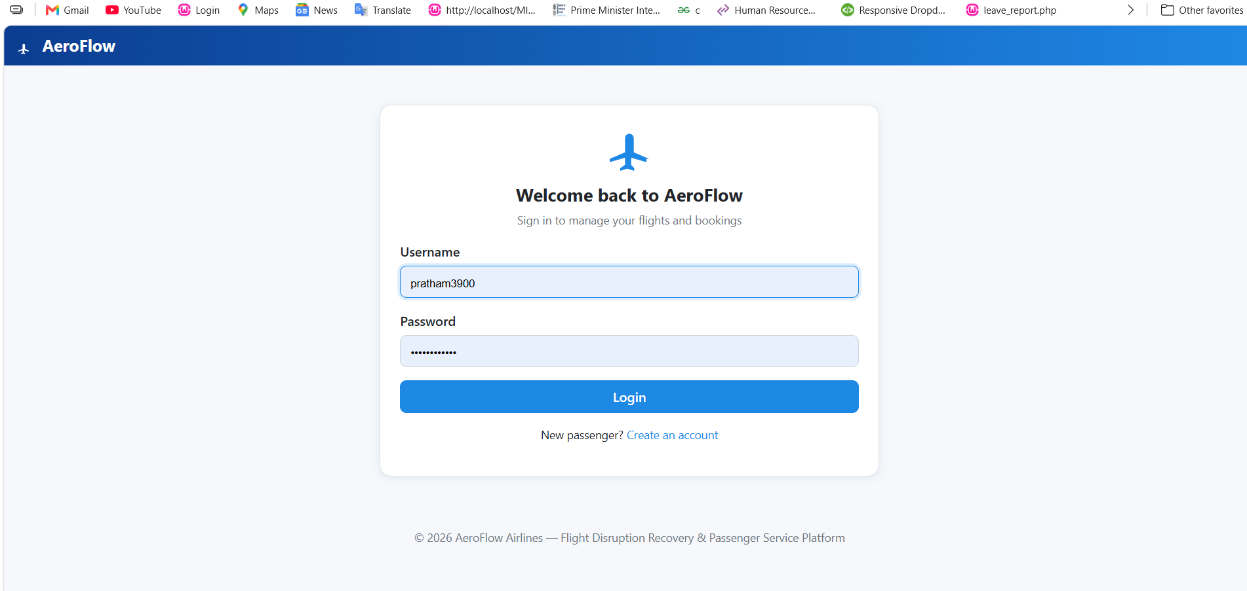
Passenger Dashboard

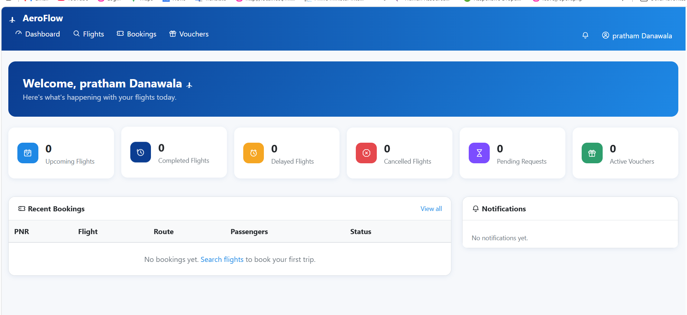

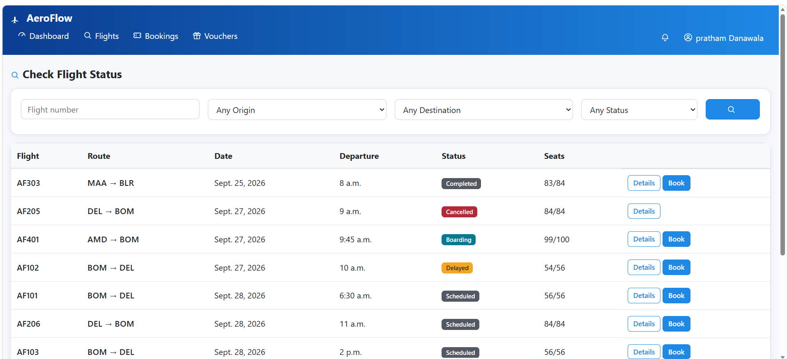

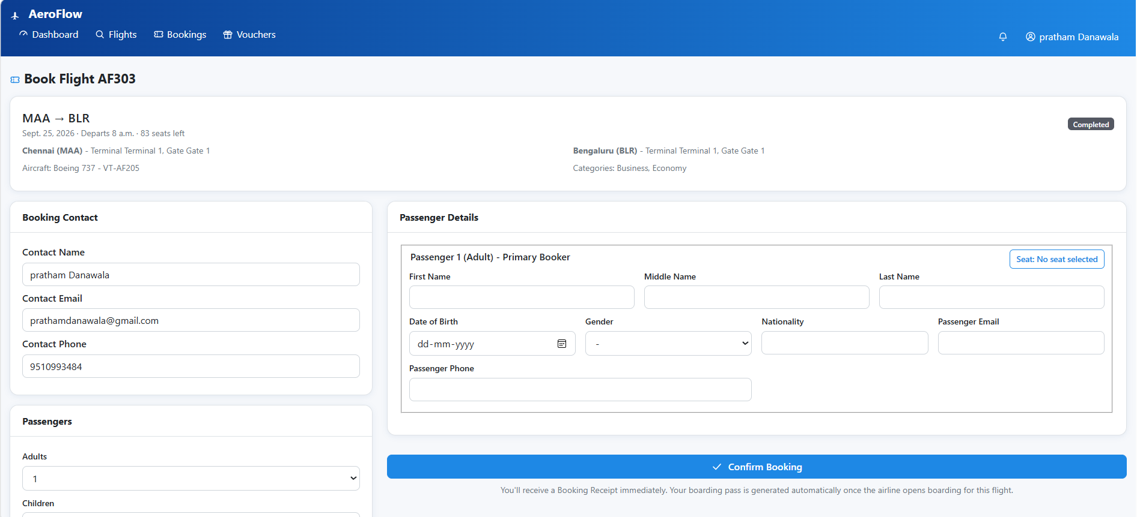

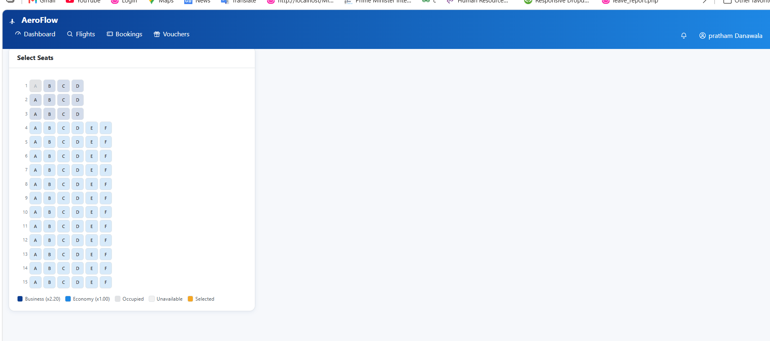

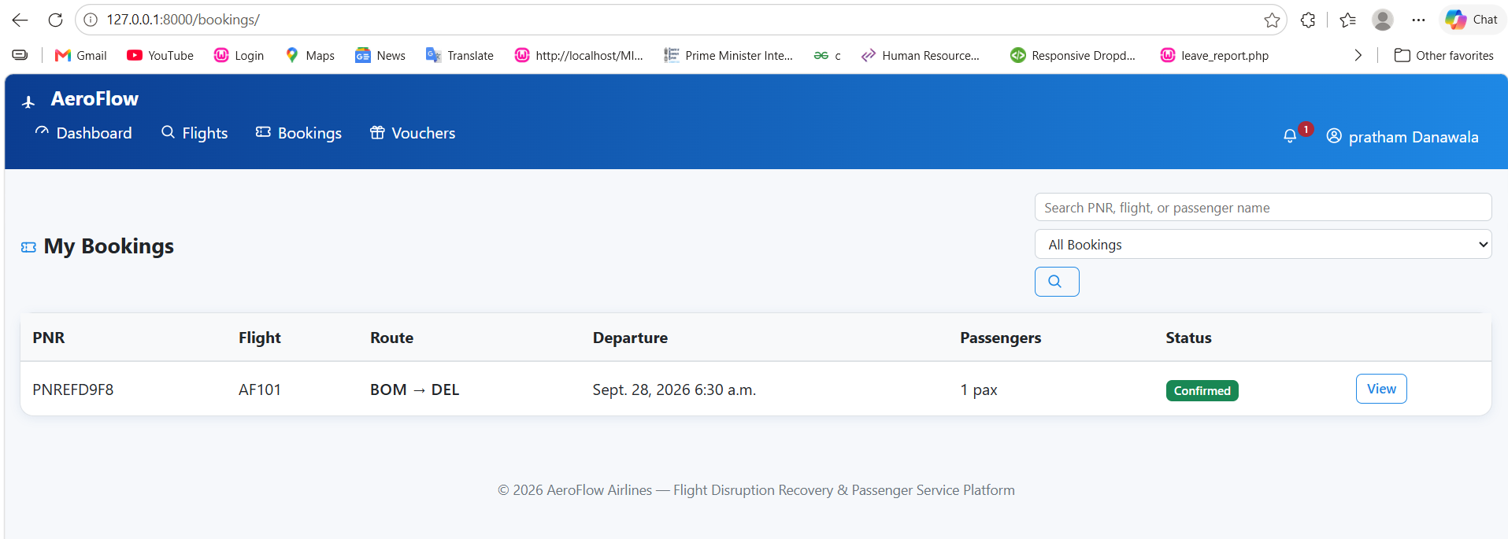

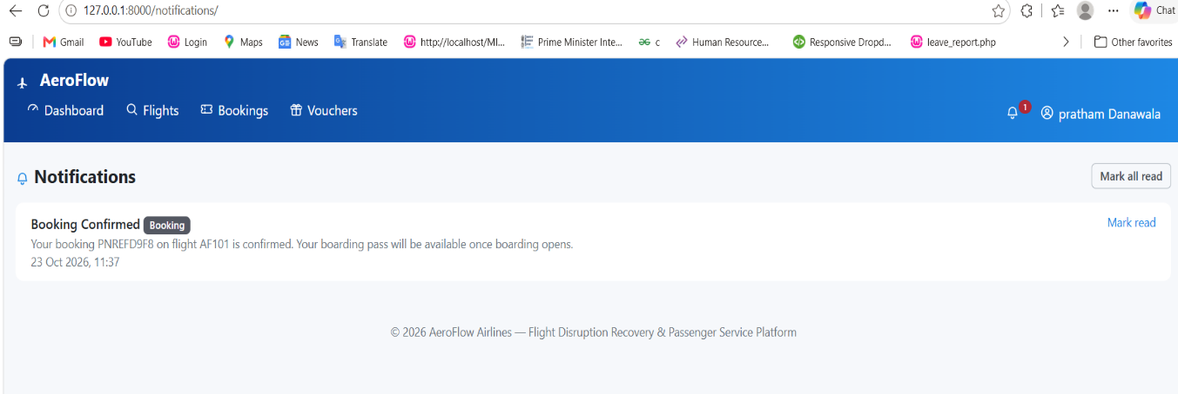

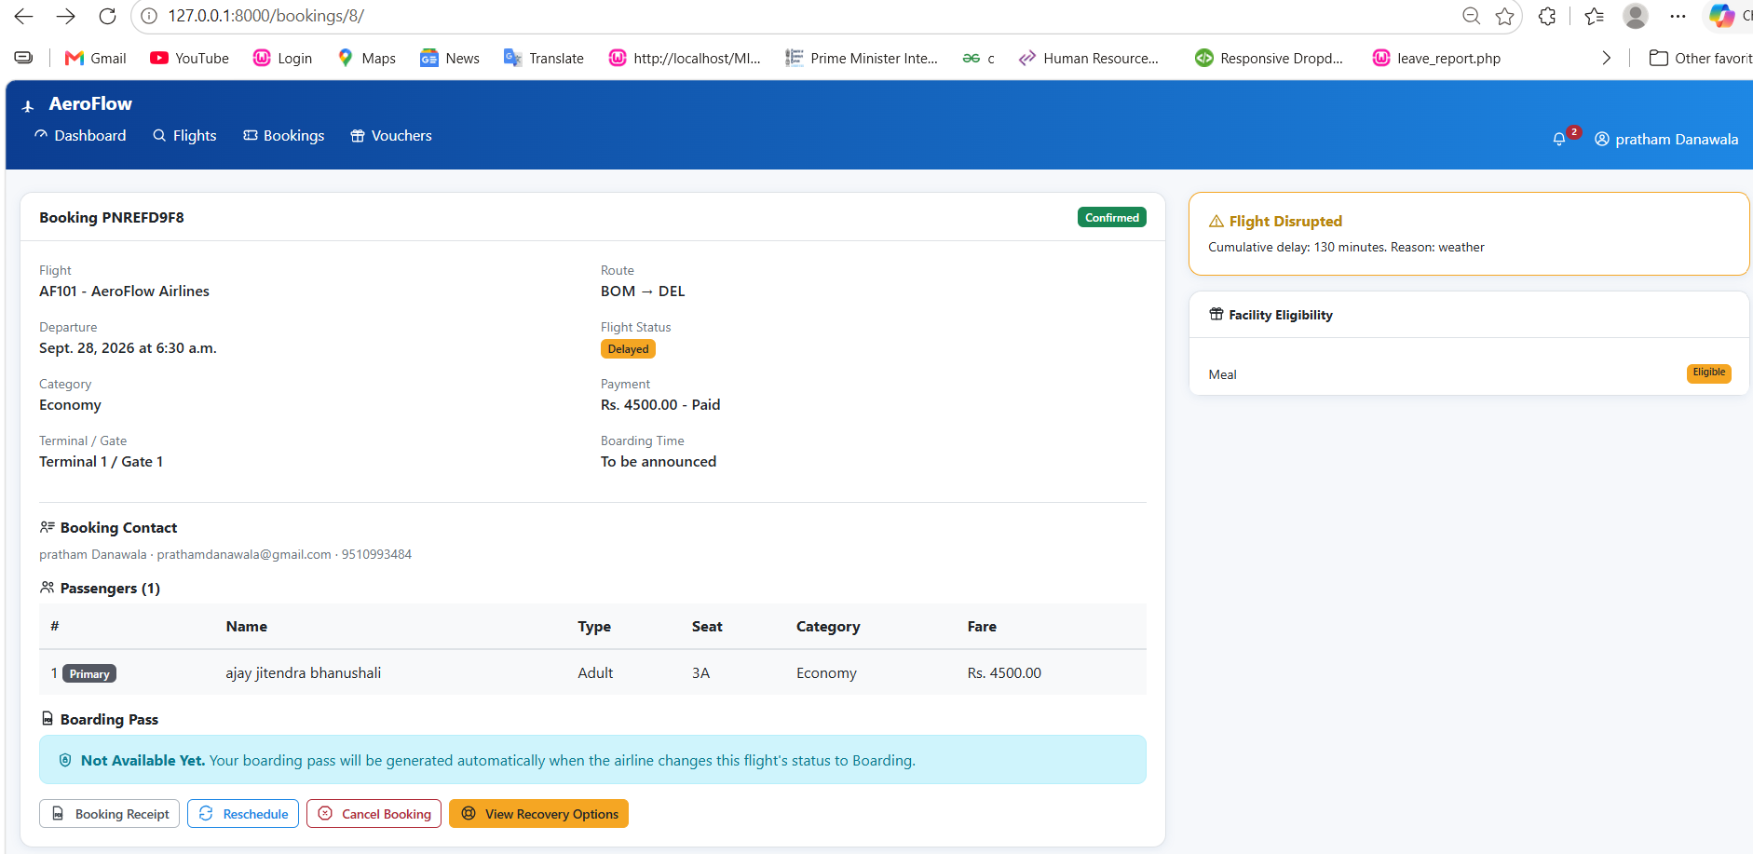

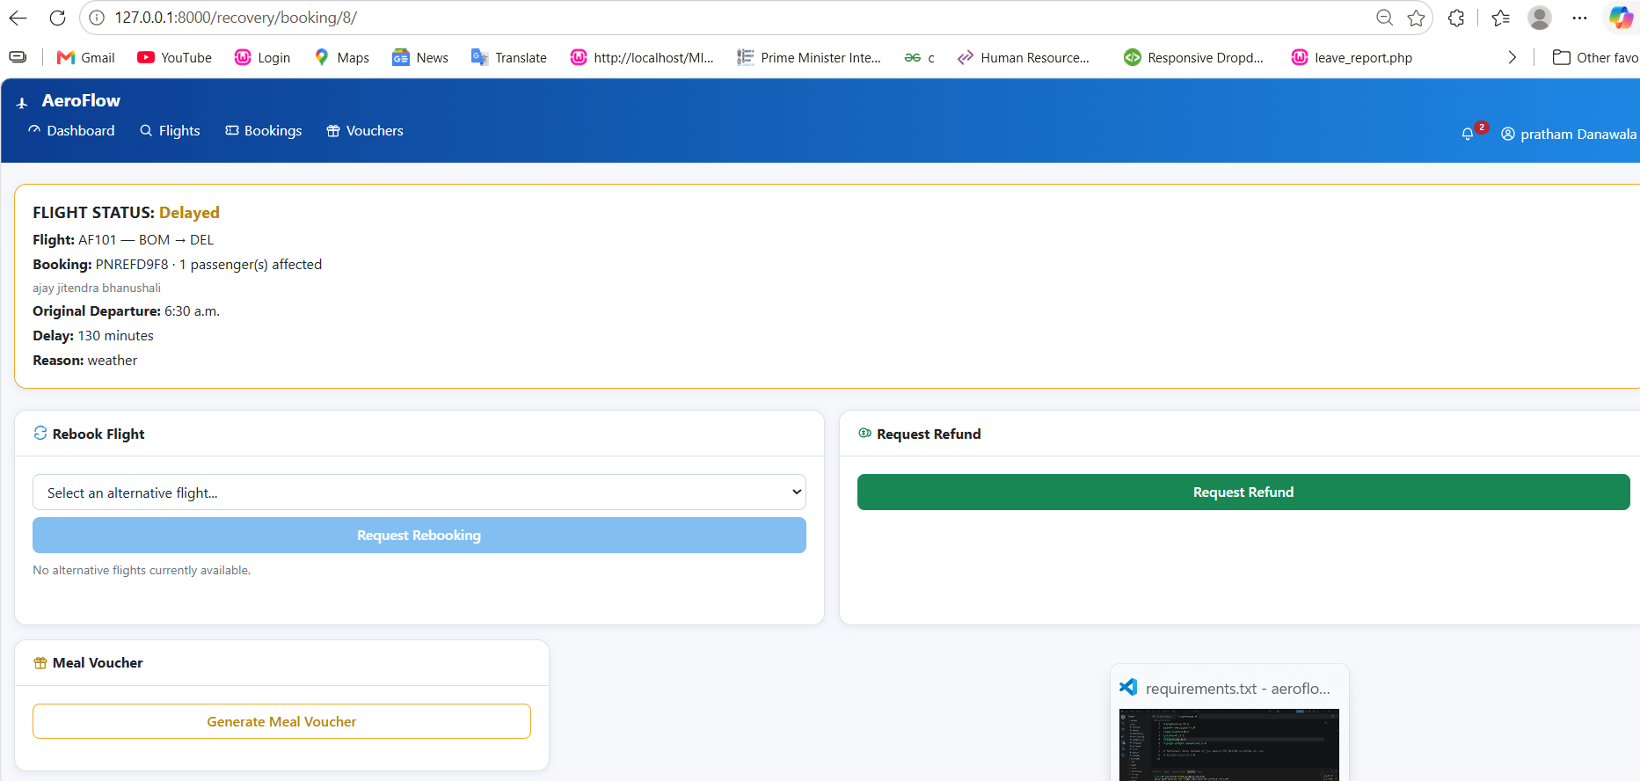

Staff Dashboard
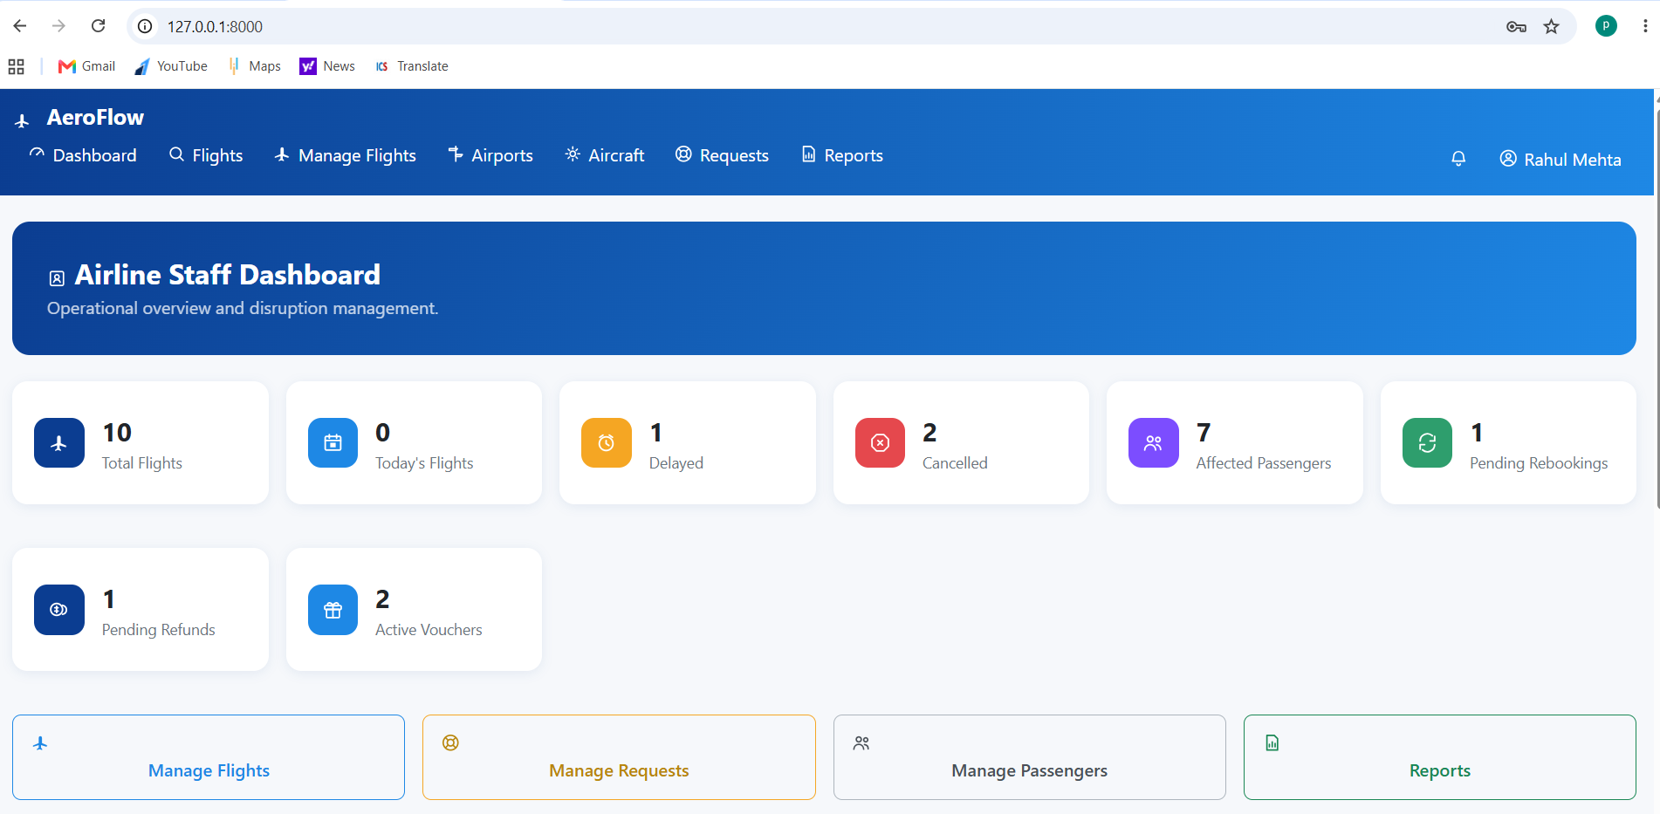

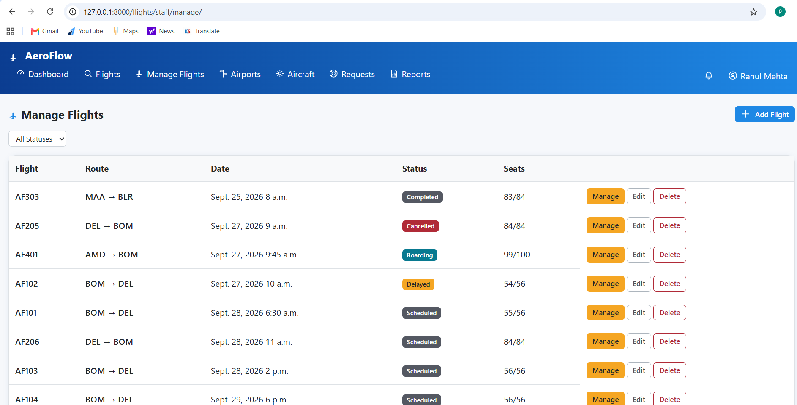

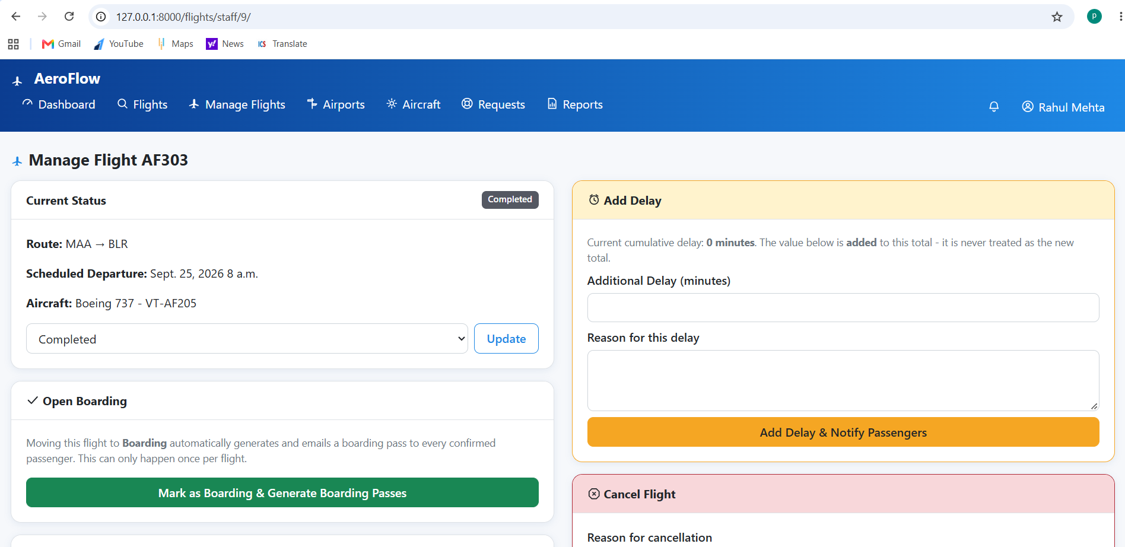
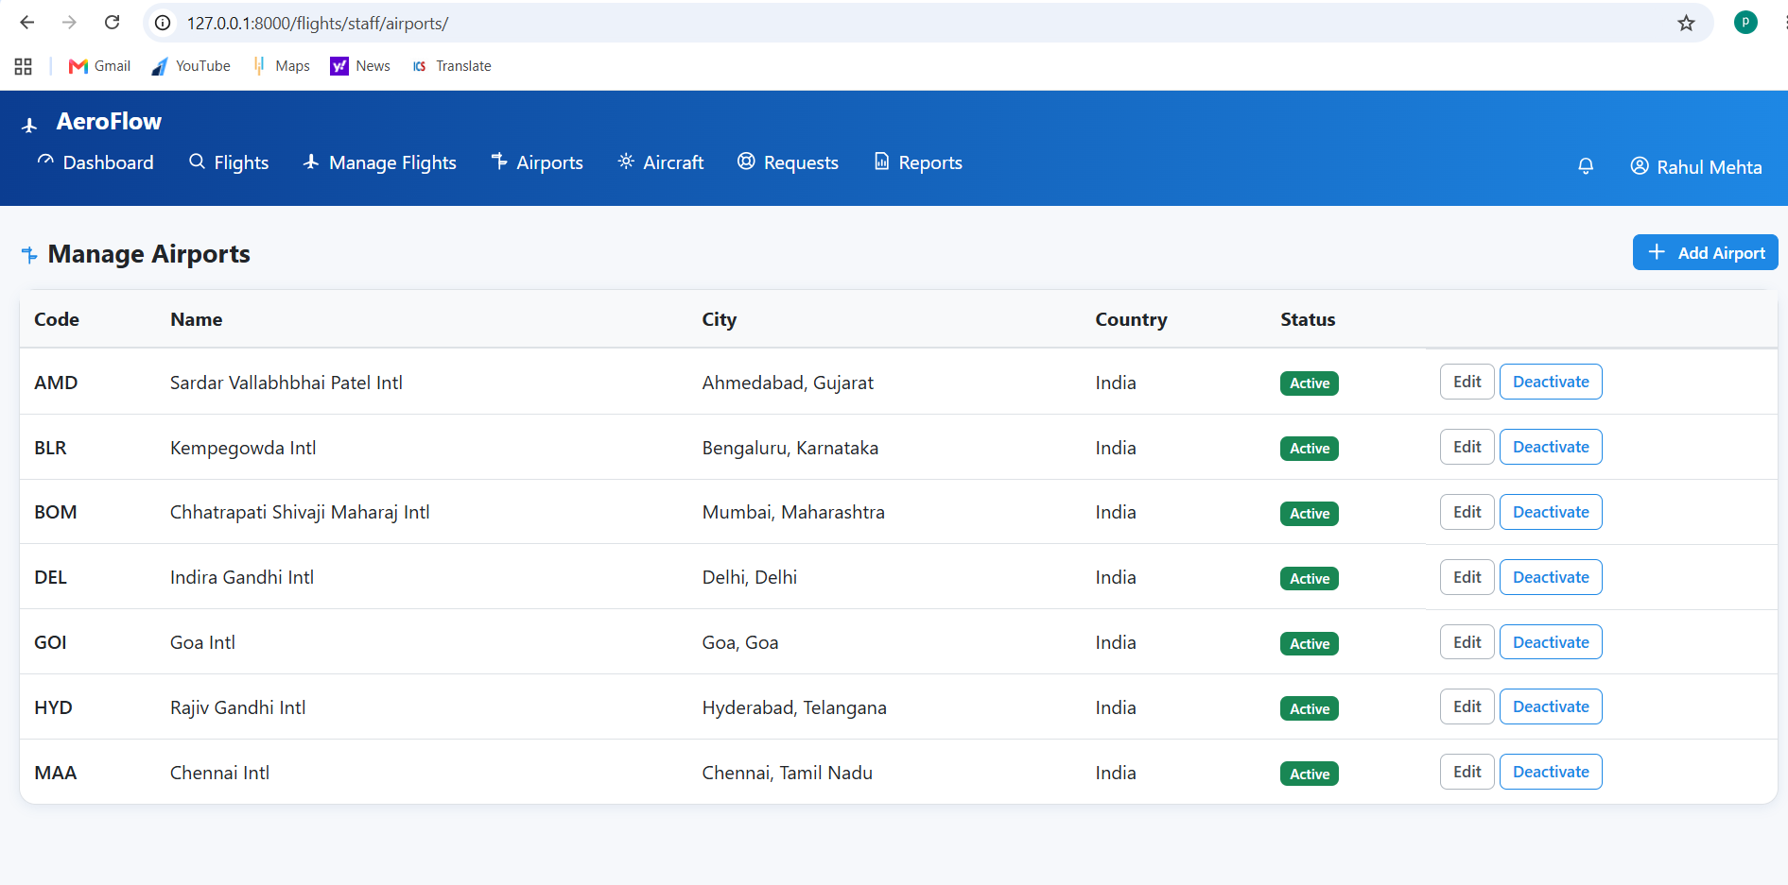

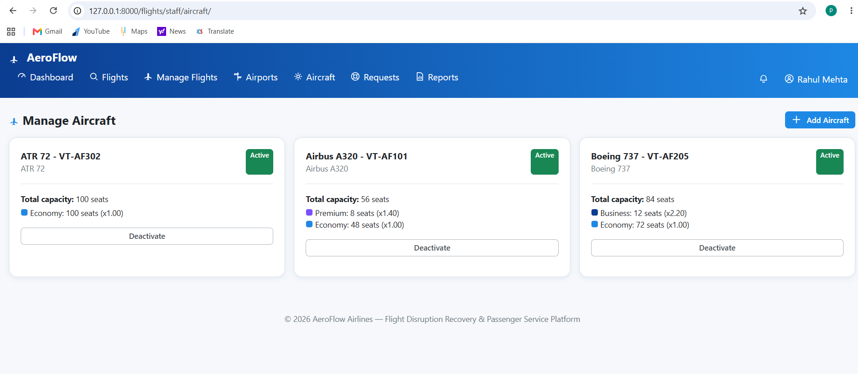

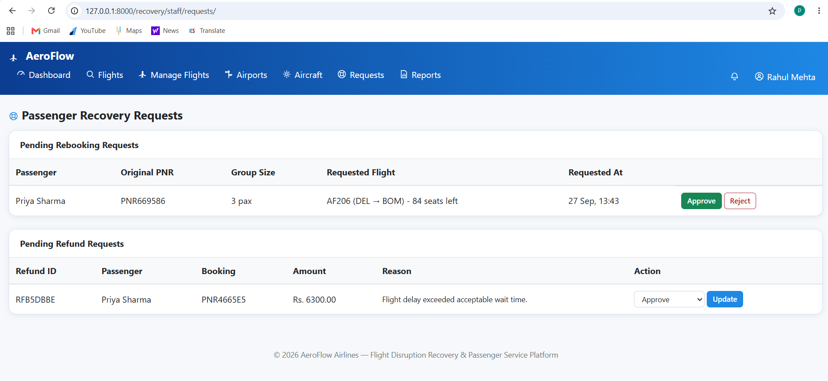
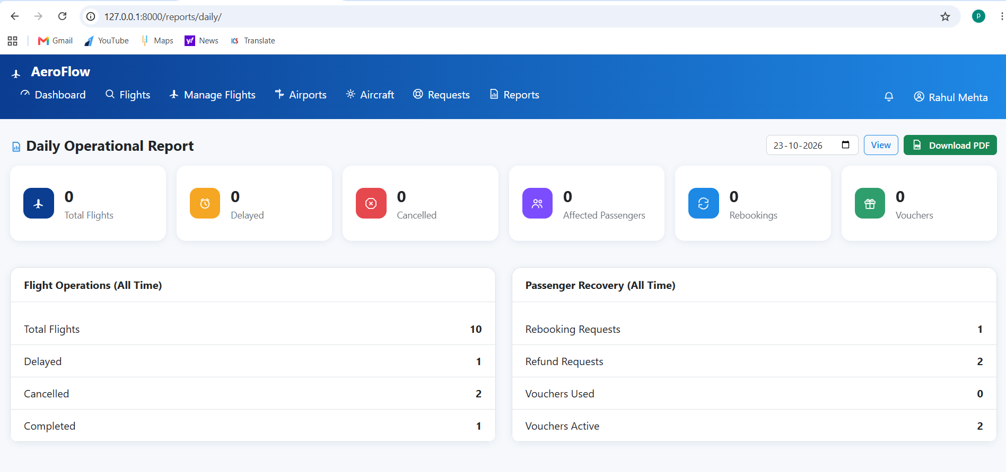

Admin Dashboard
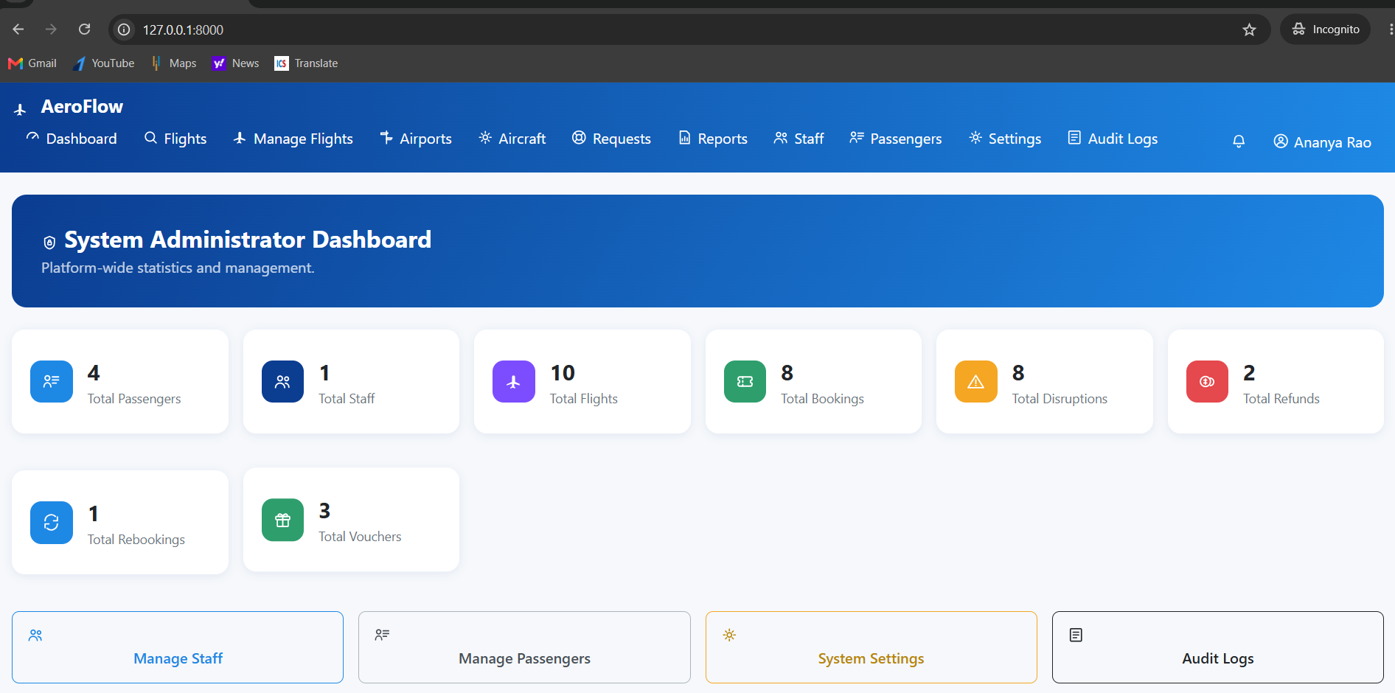

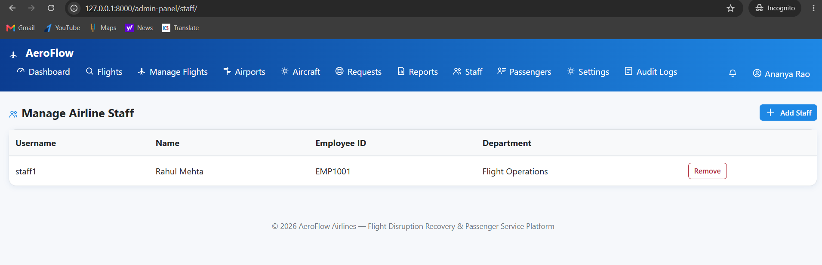

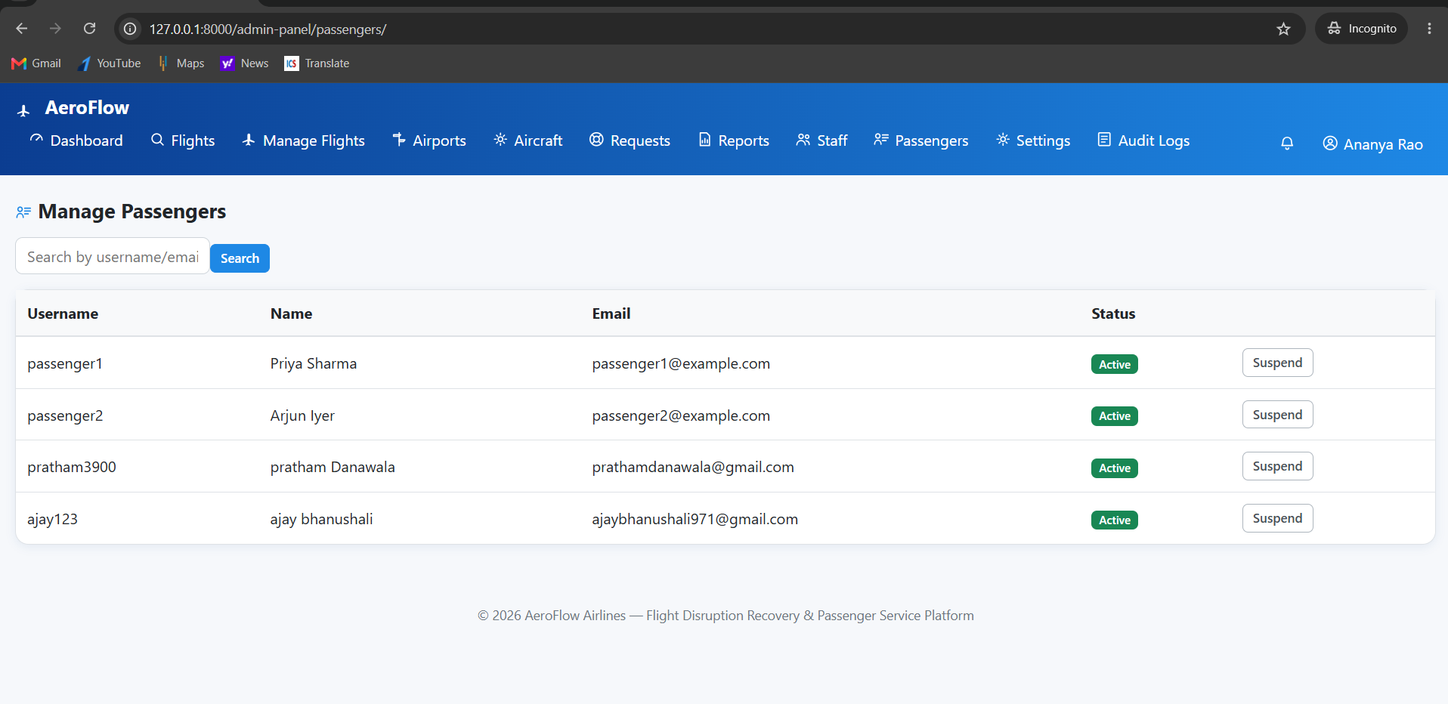
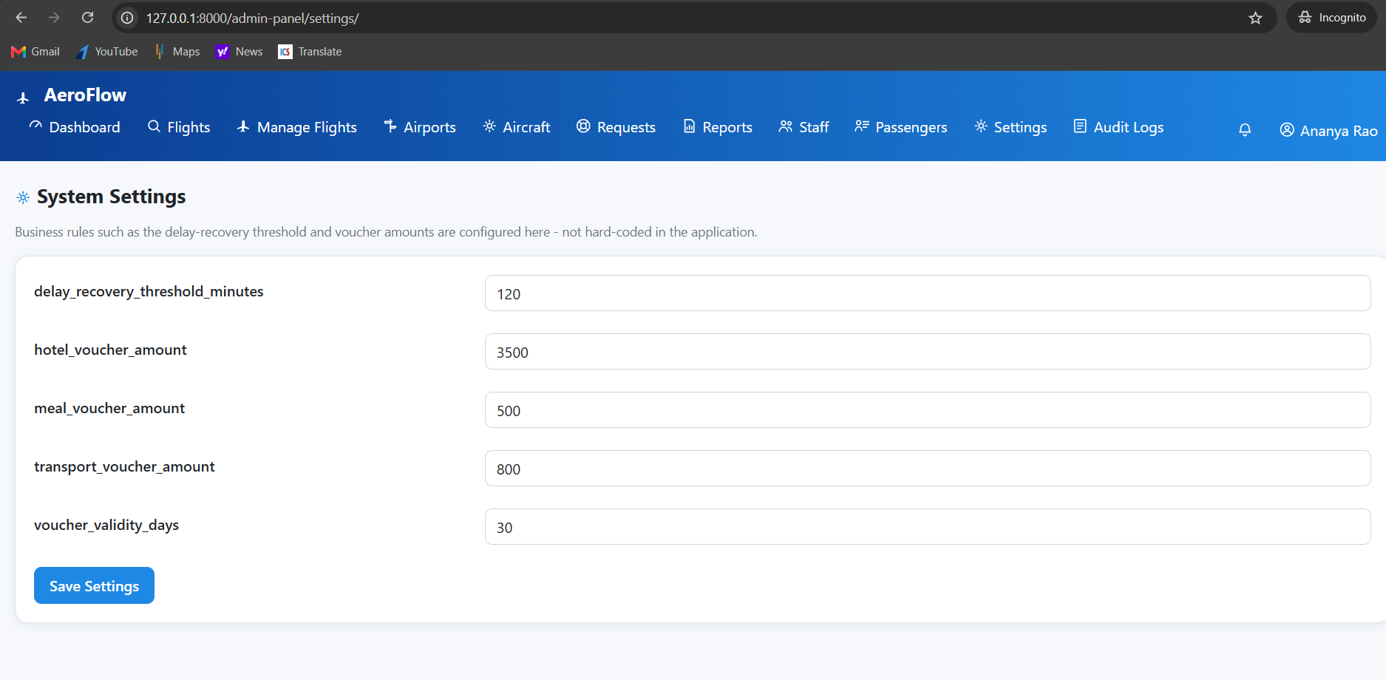

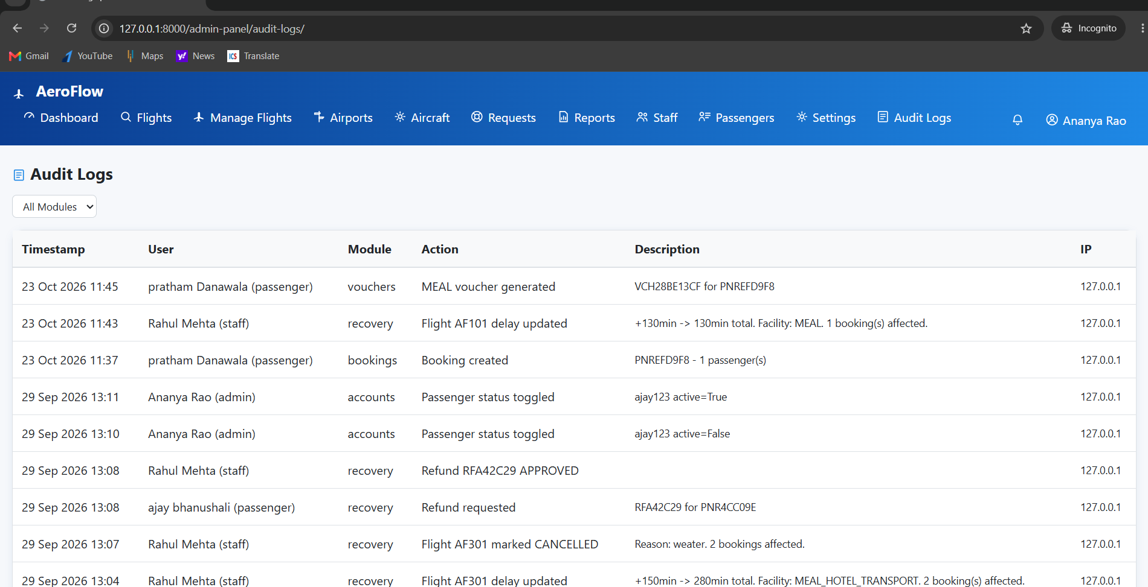

- Reports

Booking Receipt
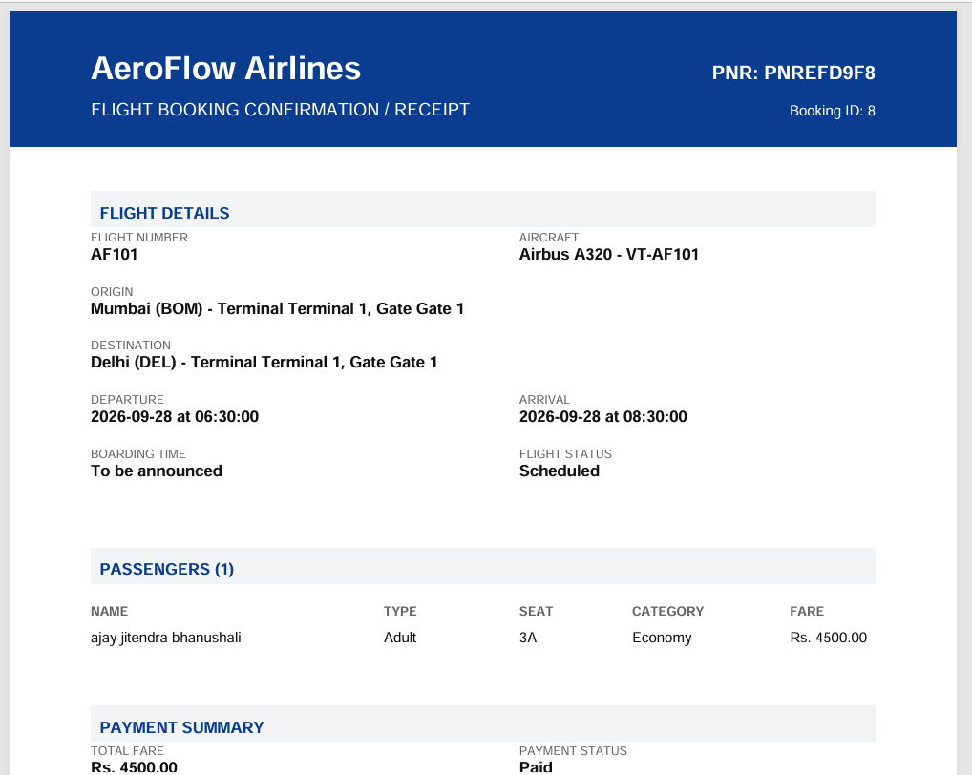
Boarding pass
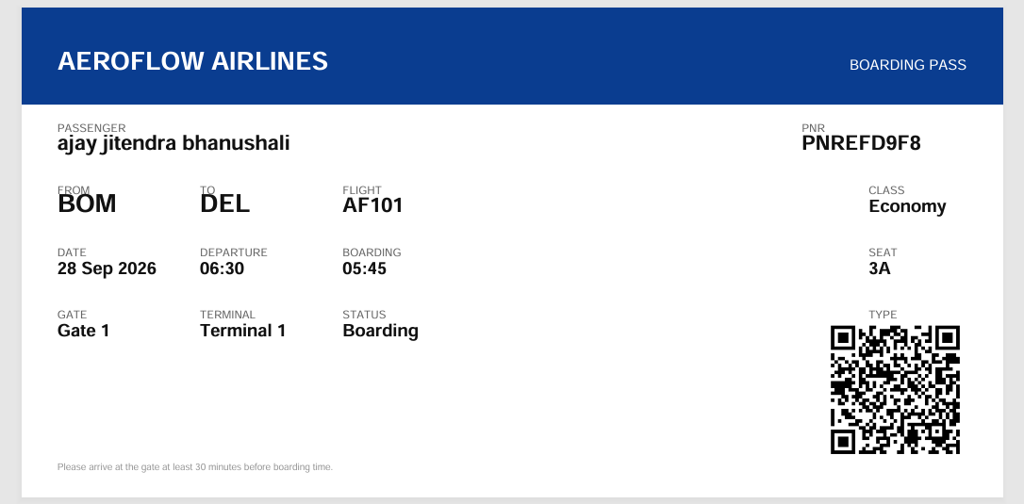
Voucher
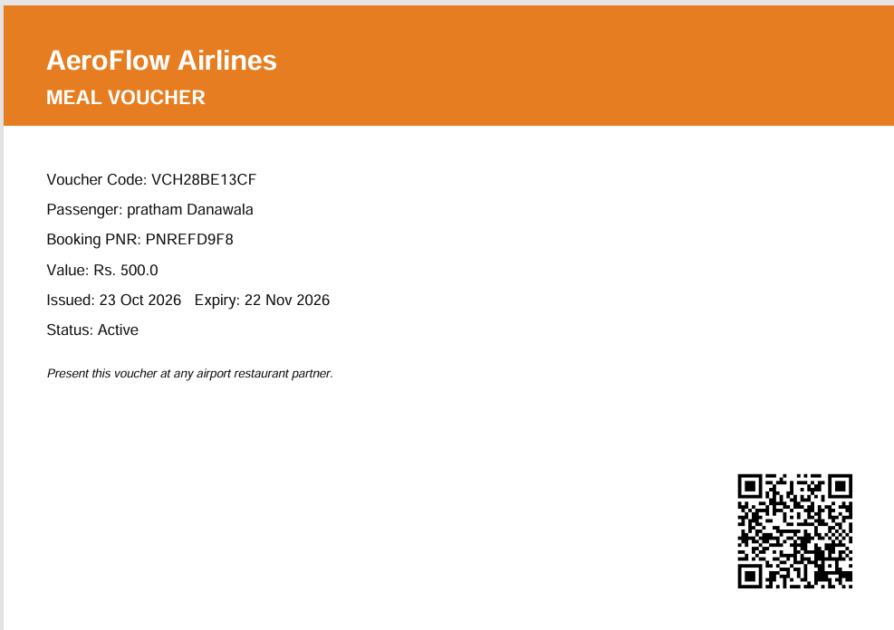
Operational Report
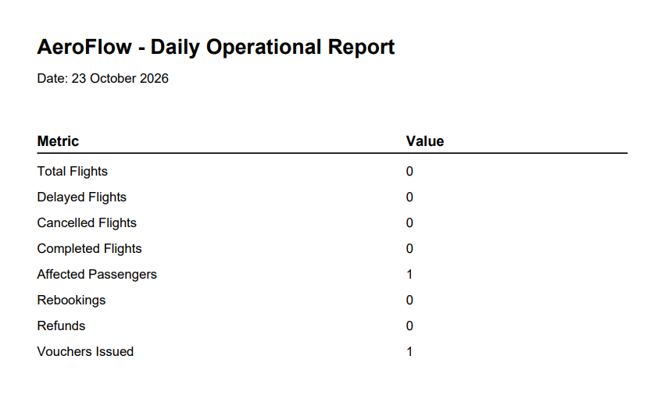

System Testing

6.1 Introduction

System testing is an important phase of software development in which the application is tested to verify that its features work according to the specified requirements. It helps identify errors, validate system functionality, and ensure that the application behaves as expected.

AeroFlow is tested to verify its passenger services, flight management operations, booking functionality, and disruption recovery workflows. Testing also helps ensure that the application handles invalid inputs and unexpected situations appropriately.

6.2 Testing Strategies

The following testing strategies can be used to test the AeroFlow application.

6.2.1 Unit Testing

Unit testing checks individual components or functions of an application separately. In AeroFlow, individual functions related to booking operations, flight management, validation, and other business logic can be tested independently.

6.2.2 Integration Testing

Integration testing verifies whether different modules work correctly together. In AeroFlow, it can be used to test interactions between passenger accounts, flight records, bookings, email notifications, and document generation.

6.2.3 Functional Testing

Functional testing verifies whether the application's features work according to their requirements. In AeroFlow, this includes testing login, flight search, booking creation, booking cancellation, rescheduling requests, and administrative flight management.

6.2.4 Validation Testing

Validation testing checks whether the application accepts valid information and rejects invalid or incomplete inputs. For example, registration forms, login forms, and booking forms can be tested using valid and invalid data.

6.2.5 System Testing

System testing evaluates the complete application as a whole. AeroFlow can be tested by performing end-to-end workflows, such as logging in, searching for a flight, creating a booking, viewing booking details, and checking the resulting documents or notifications.

6.3 Test Cases

A test case describes the input, action, expected result, and actual result of a test. The following table provides sample test cases for AeroFlow.
Note: The expected results below describe the intended behavior. Fill in the actual results and status after executing each test on your application.

Test Case ID | Test Scenario | Expected Result | Actual Result | Status
TC01 | Passenger registration with valid details | Passenger account is created successfully | To be tested | Pass
TC02 | Login with valid credentials | User is logged in successfully | To be tested | Pass
TC03 | Login with invalid credentials | Error message is displayed | To be tested | Pass
TC04 | Search for available flights | Matching flight information is displayed | To be tested | Pass
TC05 | Book a flight with valid details | Booking is created and booking details are available | To be tested | Pass
TC06 | View booking details | Correct booking information is displayed | To be tested | Pass
TC07 | Cancel an eligible booking | Cancellation workflow is processed according to the rules | To be tested | Pass
TC08 | Submit a rescheduling request | Request is recorded for the required approval workflow | To be tested | Pass
TC09 | Admin adds a new flight | Flight information is saved successfully | To be tested | Pass
TC10 | Admin updates flight status | Flight status is updated and applicable notifications are triggered | To be tested | Pass
TC11 | Generate a booking receipt | Receipt PDF is generated with the correct details | To be tested | Pass
TC12 | Generate a boarding pass when eligible | Boarding pass and QR code are generated according to the workflow | To be tested | Pass
TC13 | Enter invalid booking information | Appropriate validation message is displayed | To be tested | Pass
TC14 | Passenger logs out | User session is terminated | To be tested | Pass
TC15 | Admin manages airport terminals and gates | Valid terminal and gate records are saved without prohibited duplicates | To be tested | Pass

Future enhancement

Future Scope
The following features are planned for future enhancement of the AeroFlow – Flight Disruption Recovery & Passenger Service Platform:
1. Payment Gateway Integration: Integrate a secure online payment gateway to support booking payments, cancellation refunds, and other payment-related transactions.
2. SMS Notification Service: Implement SMS notifications to inform passengers about flight delays, cancellations, rescheduling, and booking updates.
3. WhatsApp Integration: Integrate WhatsApp messaging to send booking confirmations, flight status updates, and disruption-related notifications directly to passengers.
4. AI-Based Passenger Assistant: Develop an AI-powered assistant to answer passenger queries, provide flight information, and suggest suitable recovery options during flight disruptions.
5. Live Flight Tracking API Integration: Integrate external flight tracking APIs to provide real-time flight status, location, delay, and estimated arrival information.
6. Cloud Deployment with Kubernetes: Deploy the application on a cloud platform and use Kubernetes for container orchestration, scalability, availability, and easier application management.
7. Passenger Feedback and Rating System: Introduce a feedback system that allows passengers to rate their experience and provide suggestions for improving the platform.

bibliography/
references

Bibliography / References
1. Python Documentation. Python Software Foundation. Available at: https://docs.python.org/3/
2. Django Documentation. Django Software Foundation. Available at: https://docs.djangoproject.com/en/5.0/
3. SQLite Documentation. SQLite Consortium. Available at: https://www.sqlite.org/docs.html
4. ReportLab Documentation. ReportLab. Available at: https://docs.reportlab.com/
5. Python qrcode Library. Available at: https://pypi.org/project/qrcode/
6. Pillow Documentation. Pillow Contributors. Available at: https://pillow.readthedocs.io/
7. Git Documentation. Available at: https://git-scm.com/doc

